**PIZZA SALES SQL QUERIES**

**A. KPI’s**

**1. Total Revenue:**

select round(sum(total_price),2) Total_Revenue

from pizza_sales



**2. Average Order Value**

select round(sum(total_price)/count(distinct order_id),2) Avg_Order_Value

from pizza_sales



**3. Total Pizzas Sold**

select sum(quantity) Total_Pizza_Sold

from pizza_sales



**4. Total Orders**

select count(distinct order_id) Total_Orders

from pizza_sales



**5. Average Pizzas Per Order**

select cast(cast(sum(quantity) as decimal (10,2))/

cast(count(distinct order_id) as decimal (10,2)) as decimal (10,2))

as Avg_Pizza_Per_Order

from pizza_sales



**B. Daily Trend for Total Orders**

select

datename (weekday, order_date) Order_Day,

count(distinct order_id) Total_Orders

from pizza_sales

group by datename (weekday, order_date)

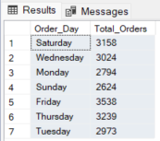

**C. Monthly Trend for Orders**

select

datename (month, order_date) Month_Name,

count(distinct order_id) Total_Orders

from pizza_sales

group by datename (month, order_date)

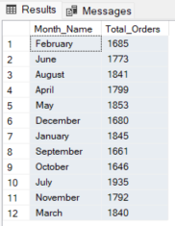

**D. % of Sales by Pizza Category**

select

distinct pizza_category,

cast(sum(total_price) as decimal (10,2)) Total_Revenue,

cast(sum(total_price)*100/(select sum(total_price) from pizza_sales) as decimal (10,2)) PCT

from pizza_sales

group by pizza_category

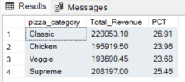

**E. % of Sales by Pizza Size**

select

distinct pizza_size,

cast(sum(total_price) as decimal (10,2)) Total_Revenue,

cast(sum(total_price)*100/(select sum(total_price) from pizza_sales) as decimal (10,2)) PCT

from pizza_sales

group by pizza_size

order by pizza_size

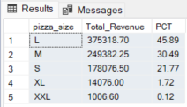

**F. Total Pizzas Sold by Pizza Category**

select pizza_category, sum(quantity) Total_Quantity_Sold

from pizza_sales

group by pizza_category

order by Total_Quantity_Sold desc

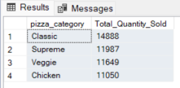

**G. Top 5 Pizzas by Revenue**

select top 5 pizza_name, sum(total_price) Total_Revenue

from pizza_sales

group by pizza_name

order by Total_Revenue desc

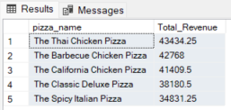

**H. Bottom 5 Pizzas by Revenue**

select top 5 pizza_name, sum(total_price) Total_Revenue

from pizza_sales

group by pizza_name

order by Total_Revenue

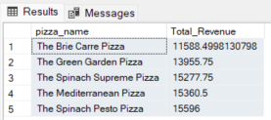

**I. Top 5 Pizzas by Quantity**

select top 5 pizza_name, sum(quantity) Total_Quantity

from pizza_sales

group by pizza_name

order by Total_Quantity Desc

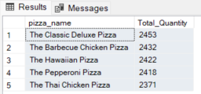

**J. Bottom 5 Pizzas by Quantity**

select top 5 pizza_name, sum(quantity) Total_Quantity

from pizza_sales

group by pizza_name

order by Total_Quantity

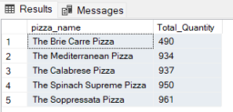

**K. Top 5 Pizzas by Total Orders**

select top 5 pizza_name, count(distinct order_id) Total_Orders

from pizza_sales

group by pizza_name

order by Total_Orders Desc

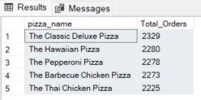

**L. Bottom 5 Pizzas by Total Orders**

select top 5 pizza_name, count(distinct order_id) Total_Orders

from pizza_sales

group by pizza_name

order by Total_Orders

